RLHS National History Day 2016-17 – Benchmark Assignment Due Dates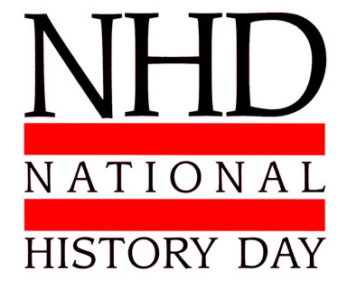

- These dates represent final due dates, materials may always be handed in earlier for more feedback
- It is critical that you bring projects and materials for scheduled work days to make use of your time.

- Thursday or Friday, October 6th or 7th Final Approval of Research Topics and Groups

- Thursday or Friday, October 20th or 21st Submit Project Type, Initial Bibliography and Initial Thesis

- Thursday or Friday, November 10th or 11th PROJECT PLAN ! (all projects must include an updated thesis and bibliography with annotations!)
  - Performances must include the current rough draft of your script. Students should also hand in information and stage direction that includes characters, roles, props, and any basics of the performance. It is a good idea to perform/film what you have out loud to help with timing.
  - Exhibits must hand in a layout of their project which must include a rough draft text of written material. This should include a detailed rendering of shape, color, design, etc., along with a list of any materials needed for the construction and how they will be obtained
  - Documentaries must include a functional rough draft video of what has been produced so far that can be shown to the teacher. This should include elements such as: titles, music, clips, credits, etc. Seek out technical help from your teacher if you are struggling to make it work.
  - Websites should include tab organization (including a bibliography and process essay tab) and rough drafts of written content for each tabbed page. Students must provide their teacher with an accurate web address for their site in the format (http://########.nhd.weebly.com/) Site construction MUST be started from the NHD web portal at http://nhd.weebly.com/
  - Papers must hand a detailed outline of their paper. This must include a full draft of the introduction based on the approved thesis. It must go beyond simple topics and include a full explanation of the different sections of the paper and include an initial conclusion. Any full paragraphs must include the notation (whether parenthetical, footnotes or endnotes) of the sources you have used so far. More is better, even in rough draft format.

- Monday or Tuesday, November 21st or 22nd UPDATE DAY/ WORK DAY – 1
Thursday or Friday, December 8th or 9th UPDATE DAY/ WORK DAY – 2
  - All projects must provide an update on project progress that reflects and explains all current changes since the project plan.
  - Performance, Documentary, and Paper projects must submit current drafts of scripts or papers
  - Websites should e-mail the teacher a reminder for rechecking with the project web address.

- Thursday or Friday, December 22nd or 23rd , the days before Holiday Break PROJECT DUE!!!
  - All projects are due! Performances must make arrangements to perform for an instructor, Documentaries and Websites must be viewable, Papers should be in final draft form.
  - Performances, Exhibits, Documentaries, and Websites need not submit final process paper on this date.
  - Draft of Process Paper for all but Historical Paper projects. (must include title page, process essay and annotated bibliography)

- Tuesday, January 10th, 2017 FINAL PROCESS PAPER IS DUE – PROJECTS ARE COMPLETE
AND CAN NOW BE GRADED FOR SEMESTER GRADES!

Competition Dates: Regional at Lakeland – Register by Feb. 8th, 2017, Contest Feb. 25th, 2017
State at UW-Madison – Register by April 5th, 2017, Contest April 22nd, 2017
National @ University of Maryland – Contest Mid-June

