Chapter 4 Assessment

Part A
- Use the Key Words on page 59 of Wisconsin: Our State, Our Story to complete the following sentences:

- Around 1500, ____________________________ started traveling to North America.

- The French explorers brought_________________________

________________________ with them on their trips to study Wisconsin.

- The ________________________ ________________________ was an

_______________________ system in which the French and Indians traded animal pelts for goods and information.

- In 1634, the French explorer ______________________ _______________________ visited Indian people near Green Bay.

- The battles between the French and British for control of trading forts and water-

highways was known as the _______________________ ______________________

_________________________ _______________________.

- The word “__________________________” means to carry canoes and goods a short distance over land.
- Answer these questions.

- What Native Peoples moved into Wisconsin from the northeast?

__________________________, ___________________________, and

__________________________.

- What drew Native Peoples to Wisconsin? List three things that “pulled” them to the area.

(1). _________________________________________________________________
(2). _________________________________________________________________
(3). _________________________________________________________________

- Why were portages important during the Fur Trade Era?

_____________________________________________________________________________________________________________________________________________________________________________________________________________________

- Who controlled the Wisconsin fur trade before 1763? ____________________________
Part B
Use your textbook to write the answers to these Thinking Like a Historian questions:

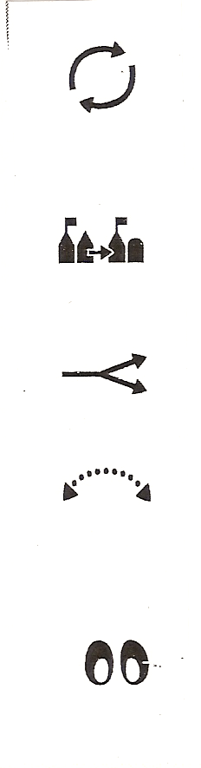 | How did early explorers find their way in Wisconsin?  ______________________________________________________________________________________________________________________________________________________________________________________________________________________________________________________________________________________________________________________________________________________________________________________________________________________________________________________________________________________________________________________________________________________________________________________________________________________________________________________
How did the lives of Wisconsin Indians change because of the fur trade?

_______________________________________________________________________________________________________________________________________________________________________________________________________________________________________________________________________________________________________________________________________________________________________________________________________________________________________________________________________________________________________________________________________________________________________________

What kinds of changes in the fur trade in Wisconsin were so large that historians see them as turning points?

____________________________________________________________________________________________________________________________________________________________________________________________________________________________________________________________________________________________________________________________________________________________________________________________________________________________________________________________________________________________________________________________________________________________________________________________________________________________________________________________________________________________________________________________

How is exploration and exchange still part of what we do today?
________________________________________________________________________________________________________________________________________________________________________________________________________________________________________________________________________________________________________________________________________________________________________________________________________________________________________________________________________________________________________

