Chapter 5 Assessment

Part A
Use the Key Words on page 81 to complete the following sentences.

- After 1815, new groups of people moved into Wisconsin’s lead region, which was then

considered the ________________________.

- When Black Hawk and his people crossed the Mississippi to go back to their homelands,

they saw Illinois ________________________ troops.

- As Black Hawk’s people tried to swim across the Bad Axe River, soldiers on a gunboat

__________________________ many of them.

- After the Black Hawk War, many Indians in Wisconsin had to

___________________________ their land to the U.S. government.

- Belmont was the first ___________________________ of the Wisconsin

____________________________.

- Wisconsin _________________________ had to write a constitution before Wisconsin could become a state.

- The ____________________________ is the chief executive of the

__________________________ branch of the Wisconsin state government.
Use your textbook to write the answers to these Thinking Like a Historian questions:
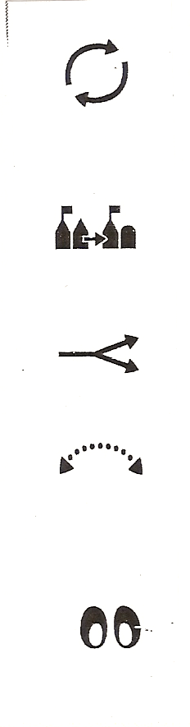 | - In what ways was the Black Hawk War a turning point for Wisconsin?  _________________________________________________________________________________________________________________________________________________________________________________________________________
- How did the signing of treaties affect Wisconsin Indians?

_________________________________________________________________________________________________________________________________________________________________________________________________________
- How did the signing of new treaties affect new settlers?

_________________________________________________________________________________________________________________________________________________________________________________________________________
- How did our state constitution define the way our government still works today?

_________________________________________________________________________________________________________________________________________________________________________________________________________

Chapter 5 Assessment

Part B

- What were three uses to which Wisconsin lead was put?

- _____________________________________________________________________
- _____________________________________________________________________
- _____________________________________________________________________

- Summarize the main events that led to the Black Hawk War. Be sure to put them in the right order. Use your Black Hawk War page to help you.

________________________________________________________________________________________________________________________________________________________________________________________________________________________________________________________________________________________________
- Name the three branches of Wisconsin government and tell what each does.

- _______________________________________________________________________________________________________________________________________________
- _______________________________________________________________________________________________________________________________________________
- _______________________________________________________________________________________________________________________________________________

